LIST OF EXPERIMENTS

S. No. | Experiments | Page no. | sign
1 | Explain following Unix Commands with syntax-
2 | Write a shell script to create a file called myfile.txt and write “Hello” in it.
3 | Write a shell script to open an already existing file named “myfile.txt” and display its content.
4 | Study & use of the Command for changing file permissions.
5 | Write a pipeline of commands, which displays on the monitor as well as saves the information about the number of users using the system at present on a file called “users.sh”.
6 | Write a shell script that accepts two numbers from user and add them.
7 | Write a shell script to find the smallest of three numbers that are read from the keyboard.
8 | Write a shell script to print the table of user given number.
9 | Write a shell script to check whether the input number is prime or
10 | Write a shell script to find the factorial of user given
11 | Write a shell script to reverse a
12 | Explain various grep commands with example.

Q1. Explain following Unix Commands with syntax-

(a) ls (b) cp (c) mv (d) wc (e) chmod (f) bc (g) ps (h) rm (i) who (j)mkdir (k)kill (l)echo

Ans- Here is a concise explanation of the listed Unix commands with their syntax and definitions:
- ls - The ls command lists files and directories in the current directory.
Syntax: ls [directory]
- cp - The cp command copies files and directories.
Syntax: cp source destination
- mv - The mv command moves or renames files and directories.
Syntax: mv source destination
- wc - The wc command counts lines, words, and characters in a file.
Syntax: wc filename
- chmod - The chmod command changes file permissions.
Syntax: chmod permissions filename
- bc - The bc command is used as a basic calculator.
Syntax: bc
- ps - The ps command displays information about running processes.
Syntax: ps
- rm - The rm command removes files and directories.
Syntax: rm filename
- who - The who command shows users currently logged in.
Syntax: who
- mkdir - The mkdir command creates new directories.
Syntax: mkdir directory_name
- kill - The kill command terminates processes.
Syntax: kill PID

Q2. Write a shell script to create a file called myfile.txt and write “Hello” in it.

Ans - # Create an empty file touch myfile.txt

# Write "Hello" into the file echo "Hello" > myfile.txt

# Display a confirmation message
echo "File 'myfile.txt' created and 'Hello' written to it."

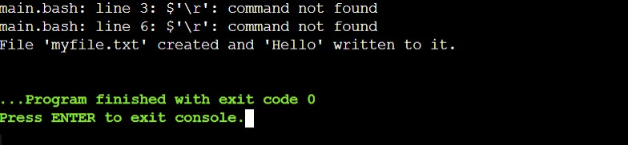
Output :

Q3. Write a shell script to open an already existing file named “myfile.txt” and display its content.

Ans- # Check if the file exists if [ -f "myfile.txt" ]; then
# Display the contents of the file cat myfile.txt
else
# If the file doesn't exist, show an error message echo "File 'myfile.txt' not found."

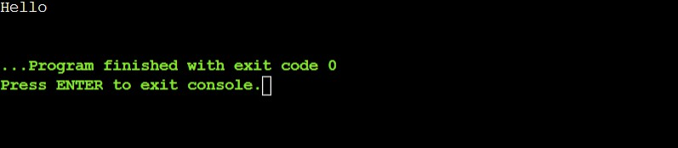
Output :

Q4. Study & use of the Command for changing file permissions.

Ans - The chmod command in Linux is used to change the file permissions of files and directories. Permissions in Linux are divided into three types: read (r), write (w), and execute (x), which can be applied to three categories of users: user (u, the file's owner), group (g), and others (o).

Symbolic Mode:
In symbolic mode, the chmod command allows users to add (+), remove (-), or set exactly (=) specific permissions for the user, group, or others. For example:
- To add read, write, and execute permissions for the user: chmod u+rwx myfile.txt
- To remove write permission for others: chmod o-w myfile.txt
- To set read-only permissions for user, group, and others: chmod u=r,g=r,o=r myfile.txt

Numeric Mode:
In numeric mode, each permission type is represented by a number. The read permission is represented by 4, write by 2, and execute by 1. Permissions are granted by adding these numbers together for each user category (user, group, others). For instance:
- 7 (rwx) for user, 5 (r-x) for group, and 5 (r-x) for others is represented as: chmod 755 myfile.txt
- To give read and write permissions to the user and only read permissions to the group and others:
chmod 644 myfile.txt

Recursive Changes:
To apply permission changes recursively to all files and subdirectories within a directory, use the -R option:
chmod -R 755 mydirectory/
This command modifies all files and directories inside mydirectory to have read, write, and execute permissions for the owner, and read and execute permissions for group and others.
Permissions on directories behave differently than on regular files. Execute permission on a directory allows users to access its contents, write permission lets them create, delete, or rename files, and read permission enables listing the directory contents.

Q5. Write a pipeline of commands, which displays on the monitor as well as saves the information about the number of users using the system at present on a file called “users.sh”.

Ans - You can use a pipeline of commands to display the number of users currently using the system and save this information to a file called users.sh. Here's how you can do it:
Code
who | wc -l | tee users.sh

Explanation:
  - who: This command lists all users currently logged into the system.
  - wc -l: This counts the number of lines in the output from who, which represents the number of users currently logged in.
  - tee users.sh: This command will:
    - Display the output on the monitor (stdout).
    - Save the output to the file users.sh.

How it Works:
- The who command lists the logged-in users.
- The output of who is piped (|) to wc -l, which counts the lines (i.e., the number of users).
- The tee command then shows the number on the terminal and saves it to users.sh.
This approach ensures that the information is both visible on the screen and saved to the file. Let me know if you need further clarification!

Output :
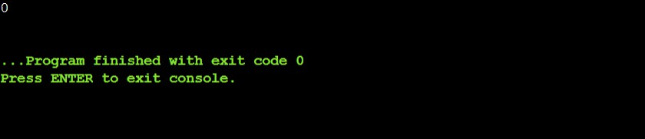

Q6. Write a shell script that accepts two numbers from user and add them.

Ans-
echo "Enter the first number: " read num1

echo "Enter the second number: " read num2

sum=$((num1 + num2))

# Display the result
echo "The sum of $num1 and $num2 is: $sum"

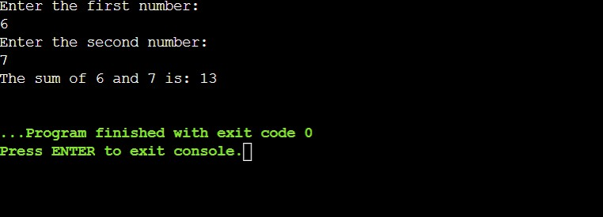
Output :

Q7. Write a shell script to find the smallest of three numbers that are read from the keyboard.
Ans –
echo "Enter the first number: " read num1

echo "Enter the second number: " read num2

echo "Enter the third number: " read num3

if [ $num1 -le $num2 ] && [ $num1 -le $num3 ]; then smallest=$num1
elif [ $num2 -le $num1 ] && [ $num2 -le $num3 ]; then smallest=$num2
else
smallest=$num3
fi
# Display the result
echo "The smallest number is: $smallest"

Output :
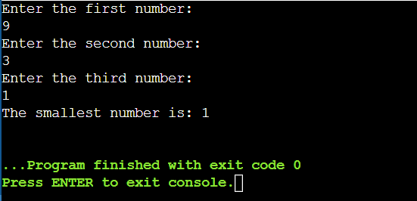

Q8. Write a shell script to print the table of user given number.

Ans-
echo "Enter a number: " read number

# Loop to print the multiplication table for i in {1..10}
do
result=$((number * i))
echo "$number * $i = $result" done

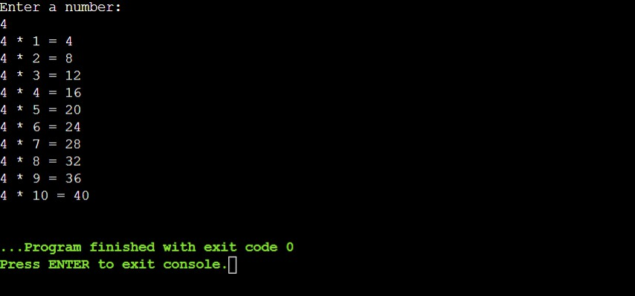
Output :

Q9. Write a shell script to check whether the input number is prime or not.
Ans –
echo "Enter a number: " read num

# Check if the number is less than 2 (not prime) if [ $num -lt 2 ]; then
echo "$num is not a prime number." exit
fi

# Loop to check divisibility for (( i=2; i<=num/2; i++ )) do
if [ $((num % i)) -eq 0 ]; then
echo "$num is not a prime number." exit
fi done

echo "$num is a prime number."

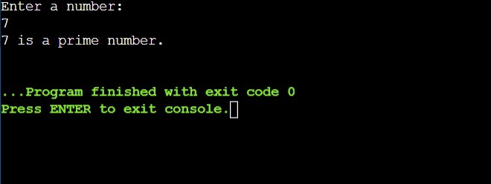
Output :

Q10. Write a shell script to find the factorial of user given number.
Ans –
echo "Enter a number: " read num

# Initialize the factorial variable factorial=1

# Loop to calculate factorial for (( i=1; i<=num; i++ )) do
factorial=$((factorial * i)) done

# Output the result
echo "The factorial of $num is $factorial"

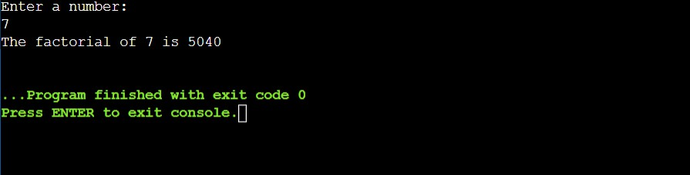
Output :

Q11. Write a shell script to reverse a number.
Ans –
echo "Enter a number: " read num

reverse=0

while [ $num -gt 0 ] do
remainder=$((num % 10)) reverse=$((reverse * 10 + remainder)) num=$((num / 10))
done

# Output the result
echo "The reversed number is: $reverse"

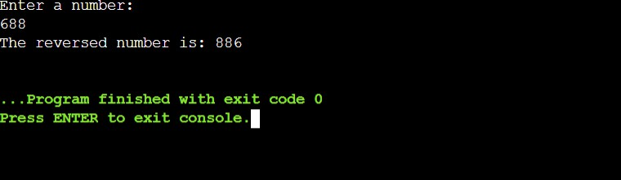
Output :

Q12. Explain various grep commands with example.
Ans - grep is a powerful command-line utility used to search for specific patterns in files or input. Here are some common grep commands and their usage:

Basic Search:
grep "pattern" filename
  - Example: grep "apple" fruits.txt
  - This command searches for the word "apple" in the file fruits.txt and prints the matching lines.

Case-Insensitive Search:
grep -i "pattern" filename
  - Example: grep -i "apple" fruits.txt
  - This command searches for "apple" (case-insensitive) in fruits.txt.

Search for Whole Words:
grep -w "word" filename
  - Example: grep -w "apple" fruits.txt
  - This searches for the whole word "apple" (not part of other words) in fruits.txt.

Display Line Numbers with Matches:
grep -n "pattern" filename
  - Example: grep -n "apple" fruits.txt
  - This command shows the line number along with the matching line from the file fruits.txt.

Invert Match (Show Lines That Do Not Match):
grep -v "pattern" filename
  - Example: grep -v "apple" fruits.txt
  - This command prints all lines from fruits.txt that do not contain the word "apple".

Count the Number of Matching Lines:
grep -c "pattern" filename
  - Example: grep -c "apple" fruits.txt
  - This command counts how many lines in fruits.txt contain the word "apple".

Search Recursively in Directories:
grep -r "pattern" directory/

  - Example: grep -r "apple" /home/user/documents
  - This command searches for "apple" recursively in all files within the directory
/home/user/documents.

Search for Multiple Patterns:
grep -e "pattern1" -e "pattern2" filename
  - Example: grep -e "apple" -e "banana" fruits.txt
  - This command searches for both "apple" and "banana" in fruits.txt.

